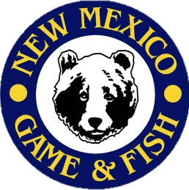C:\Users\JMorgan\Documents\Art\Logos\Bear Head\NMDGF_Logo_BW.jpgC:\Users\JMorgan\Documents\Art\Logos\Bear Head\NMDGF_Logo_BW.jpg

Special Notes

* Student worksheets must be 100% complete prior to the first class session or students will not be allowed to participate in the course (no exceptions).
* DO NOT bring firearms or ammunition to the course, firearms are provided.
* You MUST attend all course sessions. Students arriving late will not be permitted into class.
* Students under the age of 11 must be accompanied by an adult at all times during class

**If you are unable to attend, please log onto your CIN account and drop the course, or call the**

**Hunter Education Office at (505)222-4731.**

## Course Location:

**Facility Address**

**City, Zip**

New Mexico Department of

Game & Fish

Hunter Education

7816 Alamo Rd. NW

Albuquerque, NM 87120

Ph: (505) 222-4731

[www.wildlife.state.nm.us](file:///C:\Users\kboynton\AppData\Local\Microsoft\Windows\Temporary%20Internet%20Files\Content.Outlook\G1KNDJ21\www.wildlife.state.nm.us)

**Hunter Education Course**

**What do I need for class:**

1. Obtain a copy of the hunter education student manual either from [www.huntered.com/newmexico/manual/](http://www.huntered.com/newmexico/manual/) OR by picking up a hardcopy at (Location).
2. Complete worksheets from the student manual. Worksheets can be printed from the website listed above OR completed on pages 91- 94 in the back of the hardcopy student manual.
3. There are no fees associated with department Hunter Education courses;however, donations may be offered to the volunteers to help offset out-of-pocket expenses incurred to teach the course.
4. Bring a sack lunch, snacks and drinks.

## Course Schedule:

## Date

**Day Time(s)**

**Course Contact:**

**Instructor Name**

**Phone Number**

# NEW MEXICO DEPARTMENT OF GAME & FISH STUDENT INFORMATION SHEET